

**PRESIDENCY UNIVERSITY**

**SCHOOL OF COMPUTER SCIENCE AND ENGINEERING**

**CERTIFICATE**

This is to certify that the Project report **“PADDY & TOMATO PLANT DISEASE DETECTION & PEST CONTROL RECOMMENDATION USING DEEP LEARNING”** being submitted by “Mukkamalla Pragna Sree, K Monika, D. Karthik Srinivas, Nune Sai Charan Teja” bearing roll number(s) “20201CSE0087, 20201CSE0181, 20201CSE0183, 20201CSE0150” in partial fulfilment of requirement for the award of degree of Bachelor of Technology in Computer Science and Engineering is a bonafide work carried out under my supervision.



|  |  |
| --- | --- |
|  |  |

|  |  |  |  |
| --- | --- | --- | --- |
| |  |  | | --- | --- | | **Ms. AKKAMAHADEVI C**  Assistant Professor  School of CSE  Presidency University | **Dr. PALLAVI R**  Professor & HoD  School of CSE  Presidency University | |  |

|  |  |  |
| --- | --- | --- |
| **Dr. C. KALAIARASAN**  Associate Dean  School of CSE&IS  Presidency University | **Dr. SHAKKEERA L**  Associate Dean  School of CSE&IS  Presidency University | **Dr. SAMEERUDDIN KHAN** Dean  School of CSE&IS  Presidency University |

**PRESIDENCY UNIVERSITY**

**SCHOOL OF COMPUTER SCIENCE ENGINEERING**

**DECLARATION**

We hereby declare that the work, which is being presented in the project report entitled **PADDY & TOMATO PLANT DISEASE DETECTION & PEST CONTROL RECOMMENDATION USING DEEP LEARNING** in partial fulfilment for the award of Degree of **Bachelor of Technology** in **Computer Science and Engineering**, is a record of our own investigations carried under the guidance of **Ms. Akkamahadevi C, Assistant Professor,** **School of Computer Science Engineering, Presidency University, Bengaluru.**

We have not submitted the matter presented in this report anywhere for the award of any other Degree.

|  |  |  |
| --- | --- | --- |
| **Name** | **Roll number** | **Signature** |
| **MUKKAMALLA PRAGNA SREE** | **20201CSE0087** |  |
| **K MONIKA** | **20201CSE0181** |  |
| **D. KARTHIK SRINIVAS** | **20201CSE0183** |  |
| **NUNE SAI CHARAN TEJA** | **20201CSE0150** |  |

**ABSTRACT**

Introduces a groundbreaking approach for the early detection and management of leaf diseases and pests in paddy and tomato crops. Utilizing Convolutional Neural Networks (CNNs), the model accurately classifies diverse leaf diseases based on an extensive dataset. Beyond disease recognition, the system integrates intelligent pest control strategies, offering a comprehensive solution for farmers. The proactive nature of the integrated system enables timely interventions, minimizing crop damage and economic losses. Emphasizing precision agriculture, the model facilitates targeted responses to potential threats. The study's significance lies in its contribution to sustainable agriculture by promoting environmentally conscious practices through reduced reliance on conventional treatments. In essence, this research highlights the transformative potential of deep learning in advancing crop health management, ensuring enhanced yield, and fostering sustainable agricultural practices.

**ACKNOWLEDGEMENT**

First of all, we indebted to the **GOD ALMIGHTY** for giving me an opportunity to excel in our efforts to complete this project on time.

We express our sincere thanks to our respected **Dr. Md. Sameeruddin Khan**, Dean, School of Computer Science and Engineering Presidency University for getting us permission to undergo the project. We record our heartfelt gratitude to our beloved Associate Deans **Dr. C. Kalaiarasan and**

**Dr. Shakkeera L,** School of Computer Science and Engineering, Presidency University and **Dr. Pallavi R,** Head of the Computer Engineering, School of Computer Science and Engineering, Presidency University for rendering timely help for the successful completion of this project.

We are greatly indebted to our guide **Ms. Akkamahadevi C, Assistant Professor**, School of Computer Science Engineering, Presidency University for her inspirational guidance, valuable suggestions and providing us a chance to express our technical capabilities in every respect for the completion of the project work.

We would like to convey our gratitude and heartfelt thanks to the university Project-II Coordinators **Dr. Sanjeev P Kaulgud, Dr. Mrutyunjaya MS** and also the department Project Coordinators **Mr Zia Ur Rahman, Mr.Peniel Jhon Whistely.**

We thank our family and friends for the strong support and inspiration they have provided us in bringing out this project.

**MUKKAMALLA PRAGNA SREE**

**K MONIKA**

**D. KARTHIK SRINIVAS**

**NUNE SAI CHARAN TEJA**

**LIST OF TABLES**

|  |  |  |  |
| --- | --- | --- | --- |
| **Sl. No.** | **Table Name** | **Table Caption** | **Page No.** |
| 1 | Table 8.1 | Gantt chart | 23 |
| 2 | Table 8.2 | Timeline of the Project | 23 |

**LIST OF FIGURES**

|  |  |  |  |
| --- | --- | --- | --- |
| **Sl. No.** | **Figure Name** | **Caption** | **Page No.** |
| 1 | Figure 3.5.1 | Flowchart | 7 |
| 2 | Figure 4.4.1 | Architecture | 11 |
| 3 | Figure 5.1.1 | Convolutional Neural Network | 12 |
| 4 | Figure 5.1.2 | Relook Layer | 13 |
| 5 | Figure 5.1.3 | Linearly separable data points | 14 |
| 6 | Figure 6.2.1 | Use case diagram | 17 |
| 7 | Figure 6.2.2 | Class diagram | 17 |
| 8 | Figure 6.2.3 | Sequence diagram | 18 |
| 9 | Figure 6.2.4 | Collaboration diagram | 19 |
| 10 | Figure 6.2.5 | Deployment diagram | 19 |
| 11 | Figure 6.2.6 | Activity diagram | 20 |
| 12 | Figure 6.2.7 | Component diagram | 20 |
| 13 | Figure 6.2.8 | ER diagram | 21 |
| 14 | Figure 6.2.9 | DFD diagram | 22 |
| 15 | Figure 10.1 | Home page | 30 |
| 16 | Figure 10.2 | User Registration form | 31 |
| 17 | Figure 10.3 | User login page | 31 |
| 18 | Figure 10.4 | Uploading of image | 32 |
| 19 | Figure 10.5 | Result | 33 |

**TABLE OF CONTENTS**

|  |  |  |
| --- | --- | --- |
| **CHAPTER NO.** | **TITLE** | **PAGE NO.** |
|  | **ABSTRACT ACKNOWLEDGMENT** | **iv**  **v** |
| **1.** | **INTRODUCTION** |  |
|  | 1.1 GENERAL | 1 |
|  | 1.2 Objectives | 1 |
| **2.** | **LITERATURE REVIEW** | **3** |
| **3.** | **EXISTING METHODS** | **4** |
|  | 3.1 Existing method | 4 |
|  | 3.2 Disadvantages | 5 |
|  | 3.3 Proposed Method | 5 |
|  | 3.4 Advantages | 6 |
|  | 3.5 Flowchart | 7 |
| **4** | **SYSTEM REQUIREMENT ANALYSIS** | **8** |
|  | 4.1 Functional and non- functional requirements | 8 |
|  | 4.2 Hardware components | 10 |
|  | 4.3 Software components | 10 |
|  | 4.4 Architecture | 11 |
| **5** | **PROPOSED METHODOLOGY** | **12** |
|  | 5.1 Convolutional Neural Network | 12 |
| **6** | **SYSTEM DESIGN** | **15** |
|  | 6.1 Introduction of Input design | 15 |
|  | 6.2 UML diagrams | 16 |
| **7** | **IMPLEMENTATION** | **23** |
| **8** | **TIMELINE FOR EXECUTION OF PROJECT** | **25** |
| **9** | **OUTCOMES** | **26** |
| **10** | **RESULTS-SNAPSHOTS** | **28** |
|  | 10.1 Home page | 28 |
|  | 10.2 User registration form | 29 |
|  | 10.3 User login form | 29 |
|  | 10.4 Uploading | 31 |
|  | 10.5 Result | 31 |
| **11** | **CONCLUSION** | **32** |
| **12** | **REFERENCES** | **33** |
|  | **APPENDIX-A** | **34** |
|  | **APPENDIX-B** | **38** |
|  | **APPENDIX-C** | **41** |

**CHAPTER-1**

**INTRODUCTION**

**1.1 Sub topic-1**

In recent years, agricultural practices have undergone a transformative shift with the integration of advanced technologies, and one notable development is the application of deep learning in leaf disease classification. Focusing on two crucial crops, paddy and tomato, pest controllers this study aims to address the pressing challenges posed by plant diseases through innovative technological solutions. The health of crops is paramount for global food security, and timely detection of diseases is essential to mitigate yield losses. Leveraging deep learning algorithms, specifically tailored for paddy and tomato plants, offers a promising avenue for accurate and rapid identification of leaf diseases. This research investigates the intersection of agriculture and artificial intelligence, contributing to the creation of efficient, automated systems capable of enhancing crop disease management. The outcomes of this study have the potential to revolutionize farming practices, ensuring sustainable crop production and safeguarding the livelihoods of farmers worldwide

**1.2 Sub topic-2 OBJECTIVES:**

**Image Data Collection:**

The dataset consists of high-quality images of Paddy and Tomato plants, encompassing various growth stages and environmental conditions.

**Data Preprocessing:**

The process involves cleaning and preprocessing image data to eliminate noise and inconsistencies, and performing data augmentation techniques to increase dataset diversity.

**Deep Learning Model Development:**

Design a deep learning architecture for image classification tasks, like Convolutional Neural Networks, and train it on a preprocessed dataset for Paddy and Tomato plant classification.

**Integration of Disease Detection Model:**

Develop an integrated system that allows users to upload images of Paddy and Tomato plants.

Implement the trained deep learning model to automatically detect and classify diseases in the uploaded images.

**Pest Control Recommendation System:**

Integrate a recommendation system that suggests appropriate pest control measures based on the identified diseases.

Utilize a knowledge base of effective pesticides, fungicides, or cultural practices for controlling specific diseases in Paddy and Tomato plants.

**User-Friendly Interface:**

The system should be designed with a user-friendly interface that includes features like image upload, disease detection, and recommended pest control measures.

**Real-Time Monitoring:**

Implement a system for real-time monitoring of plant health, allowing users to regularly check the status of their crops.

**Alerts and Notifications:**

Set up an alert system to notify users when potential diseases are detected.

Provide timely recommendations for pest control to prevent further damage to the crops.

**Continuous Improvement:**

Implement mechanisms for continuous learning and improvement of the deep learning model as more data becomes available.

Update the knowledge base for pest control recommendations based on emerging research and best practices.

**Education and Outreach:**

Include educational resources within the system to help users understand different diseases and pest control methods.

Provide tips on sustainable and environmentally friendly farming practices.

By addressing these objectives, the system can contribute to efficient and informed decision-making in agriculture, ultimately helping farmers enhance crop yield and reduce the impact of diseases on their Paddy and Tomato plants.

**CHAPTER-2**

**LITERATURE SURVEY**

**[1] Title: Advancements in CNN-Based Leaf Disease Classification Models**

This literature review explores recent developments in Convolutional Neural Network (CNN)-based models for leaf disease classification in agriculture. The survey covers various CNN architectures, transfer learning techniques, and datasets used in training these models. Additionally, it discusses challenges faced in real-world applications and the potential of recent advancements to overcome these limitations.

**[2]** **Title: Comparative Analysis of CNNs for Leaf Disease Classification**

This literature survey compares different CNN architectures, including AlexNet, VGGNet, ResNet, and InceptionNet, in the context of leaf disease classification. The study delves into the strengths and weaknesses of each architecture, evaluating their performance on benchmark datasets. Insights from this review contribute to the selection of the most suitable CNN model for effective leaf disease identification.

**[3] Title: Transfer Learning Strategies in CNNs for Leaf Disease Detection**

Focused on transfer learning, this literature survey investigates various strategies for adapting pre-trained CNN models to the task of leaf disease classification. The review covers methods such as feature extraction, fine-tuning, and domain adaptation, providing an in-depth analysis of their effectiveness in improving model performance on plant disease datasets.

**[4] Title: Challenges and Solutions in CNN-Based Leaf Disease Classification**

Addressing the challenges associated with CNN-based leaf disease classification, this literature review discusses issues like limited labeled data, class imbalances, and environmental variations. It explores existing solutions proposed in the literature to mitigate

these challenges, offering insights into potential strategies for developing more robust and generalizable models.

**CHAPTER-3**

**EXISTING METHODS**

**3.1 EXISTING METHOD**

The existing methods for the project "Leaf Disease Classification by Using Deep Learning with CNN Algorithms" involve the application of Convolutional Neural Networks (CNNs) for accurate and efficient identification of plant diseases based on leaf images. Researchers have leveraged established CNN architectures, adapting and fine-tuning them for the specific task of plant disease classification. Transfer learning, a key strategy, involves pre-training these CNN models on large datasets like ImageNet and subsequently fine-tuning them on plant disease datasets. This approach facilitates faster convergence and improved performance, even in scenarios with limited labeled data.

Datasets play a pivotal role, and researchers commonly utilize well-annotated datasets such as PlantVillage and FER2013, which include images of leaves exhibiting various diseases and conditions. The availability and quality of these datasets contribute significantly to the robustness of the trained models. Transfer learning, combined with diverse datasets, helps address challenges such as class imbalances, limited access to labeled data, and variations in environmental conditions.

Moreover, recent advancements in the field have seen efforts to enhance model interpretability and accuracy. Researchers have explored attention mechanisms, ensembles, and the integration of spectral and multi-modal imaging data to improve disease detection accuracy. Despite these advancements, challenges persist, including the need for more diverse datasets, handling class imbalances, and ensuring model generalization to real-world agricultural settings. The existing methods lay the foundation for the project, emphasizing the importance of leveraging deep learning techniques, specifically CNNs, for precise and timely leaf disease classification in agriculture.

**3.2 DISADVANTAGES:**

**1. Limited Interpretability:**

CNNs, especially deeper architectures, often act as complex black-box models, making it challenging to interpret how decisions are made. Understanding the internal mechanisms of the model is crucial, particularly in applications like agriculture, where interpretability is essential for building trust and facilitating actionable insights.

**2. Data Scarcity and Class Imbalances:**

In many agricultural scenarios, obtaining large and diverse labeled datasets for training CNNs can be challenging. Class imbalances, where certain diseases may be underrepresented, can result in biased models that struggle to accurately identify less prevalent diseases.

**3. Overfitting and Generalization:**

CNNs may be prone to overfitting, especially when trained on limited datasets. Overfit models may perform well on training data but fail to generalize effectively to new, unseen data, impacting the model's reliability in real-world applications.

**4. Computational Intensity:**

Training deep CNN models can be computationally intensive, requiring substantial computing resources. This can limit the accessibility of these methods for researchers or practitioners with constrained computational infrastructure.

**5. Sensitivity to Image Quality and Conditions:**

CNNs may be sensitive to variations in image quality, lighting conditions, and background clutter. In agricultural settings, where environmental conditions can be unpredictable, the robustness of CNN models to such variations is critical for practical deployment.

**3.3 PROPOSED METHOD**

The proposed system for "Leaf Disease Classification by Using Deep Learning with CNN Algorithms" aims to enhance model interpretability, mitigate data scarcity challenges, and improve generalization. Our approach includes incorporating attention mechanisms for finer feature discrimination, developing methods to handle class imbalances, and exploring techniques to augment limited labeled datasets. Additionally, we propose investigating model interpretability tools to demystify decision-making processes. The system will prioritize robustness to environmental variations, ensuring the CNN models generalize effectively in diverse agricultural conditions. These enhancements collectively aim to elevate the accuracy, reliability, and practical applicability of leaf disease classification in precision agriculture.

**3.4 ADVANTAGES:**

**Improved Model Interpretability:**

Integration of attention mechanisms enhances the interpretability of the CNN models, providing insights into the specific features influencing disease classification decisions.

**Addressing Class Imbalances:**

The proposed system includes strategies to handle class imbalances in the dataset, ensuring that the model is trained to accurately identify both prevalent and less common diseases.

**Data Augmentation for Limited Datasets:**

Techniques for augmenting limited labeled datasets will be employed, leveraging synthetic data generation to enhance the diversity and richness of the training dataset.

**Robustness to Environmental Variations:**

Emphasis on robustness ensures that the CNN models are resilient to variations in environmental conditions, making them more applicable in real-world agricultural settings.

**Generalization to Diverse Agricultural Conditions:**

By prioritizing generalization, the proposed system aims to develop models that can effectively classify leaf diseases across a wide range of agricultural environments and plant species.

**Increased Accuracy and Reliability:**

The combined effects of improved interpretability, balanced training data, and robustness contribute to higher accuracy and reliability in disease classification, minimizing false positives and false negatives.

**3.5 FLOW OF THE PROJECT:**

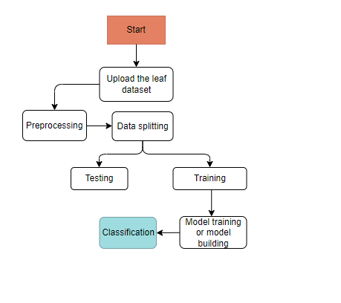

**Figure 3.5.1 Flowchart**

**CHAPTER-4**

**SYSTEM REQUIREMENT ANALYSIS**

**4.1 Functional and non-functional requirements:**

The analysis of requirements is a crucial process for assessing the success of a system or software project, categorizing them into functional and non-functional requirements.

**Functional Requirements**:

* **Image Input Processing:**

The system should be capable of pre-processing input images to standardize resolution, remove noise, and enhance features relevant to leaf disease classification.

* **CNN Model Implementation:**

The project aims to develop and refine a deep learning framework for leaf disease classification. (e.g., TensorFlow, PyTorch).

* **Transfer Learning:**

Integrate transfer learning techniques to leverage pre-trained models on general image datasets, improving the efficiency of training on limited plant disease datasets.

* **Attention Mechanisms:**

Incorporate attention mechanisms within the CNN architecture to highlight relevant image regions, enhancing interpretability and aiding in diagnosis explanation.

* **Class Imbalance Handling:**

Implement strategies to handle class imbalances in the training dataset, ensuring that the model is capable of accurately classifying both common and rare leaf diseases.

* **Data Augmentation:**

Utilize data augmentation techniques like rotation and flipping to artificially expand the dataset, enhancing the diversity and robustness of the trained model.

* **Robustness to Environmental Variations:**

Develop methods to enhance the robustness of the model to variations in lighting, background, and other environmental factors commonly encountered in agricultural settings.

* **Prediction and Classification:**

Enable the model to predict and classify the type of leaf disease present in input images with associated confidence scores.

* **Interpretability Tools:**

Implement tools for interpreting and visualizing the decision-making process of the model, aiding end-users in understanding how the system arrives at its classifications.

* **Compatibility and Integration:**

Ensure compatibility with diverse imaging devices commonly used in agriculture and allow seamless integration with existing precision agriculture systems.

**Non-functional requirements**:

* **Performance:**
* The system should achieve a high accuracy rate in leaf disease classification, with a focus on minimizing false positives and false negatives.
* **Scalability:**
* Design the system to scale efficiently, accommodating an increasing volume of data and users as the application is deployed in various agricultural contexts.
* **Response Time:**
* Specify response time requirements for image processing and classification to ensure timely disease identification, especially in real-time applications.
* **Usability:**
* Design an intuitive user interface that is user-friendly and accessible to agricultural professionals with varying technical expertise.
* **Security:**
* Implement security measures to protect sensitive data, ensuring confidentiality and integrity during data transmission and storage.
* **Reliability:**
* Ensure the system's reliability by conducting rigorous testing under diverse environmental conditions to validate consistent performance.
* **Interoperability:**
* Design the system to seamlessly integrate with other agricultural technologies and data management systems commonly used in precision agriculture.
* **Compliance:**

Adhere to relevant data protection and privacy regulations, ensuring compliance with ethical standards and legal requirements.

* **Documentation:**

The goal is to offer comprehensive documentation to end-users, administrators, and developers, including user manuals, system architecture documentation, and code documentation.

* 1. **HARDWARE REQUIREMENTS:**

Product Features:

• I3/Intel Processor

• 160GB Hard Disk

• Standard Windows Keyboard

• Two/Three Button Mouse

• SVGA Monitor

• 8GB RAM

* 1. **SOFTWARE REQUIREMENTS:**

Server Side Script Overview

• Operating System: Windows 7/8/10

• Programming Language: Python

• Libraries: Django, Pandas, MySQL.connector, Os, Smtplib, Numpy

• IDE/Workbench: PyCharm

• Technology: Python 3.6+

• Server Deployment: Xampp Server

• Database: MySQL

* 1. **ARCHITECTURE:**

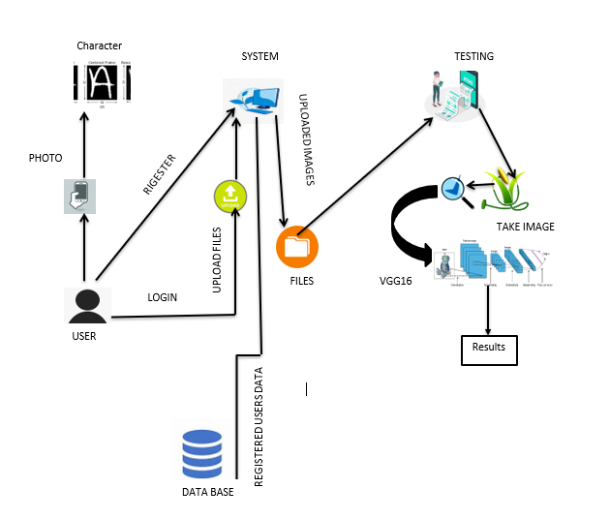

DCNN

**Figure 4.4.1 Architecture**

**CHAPTER-5**

**PROPOSED MOTHODOLOGY**

**1.Convolutional Neural Network**

**Step1: convolutional operation**

The plan of attack includes convolution operation, feature detectors, feature maps, learning parameters, pattern detection, detection layers, and mapping out findings.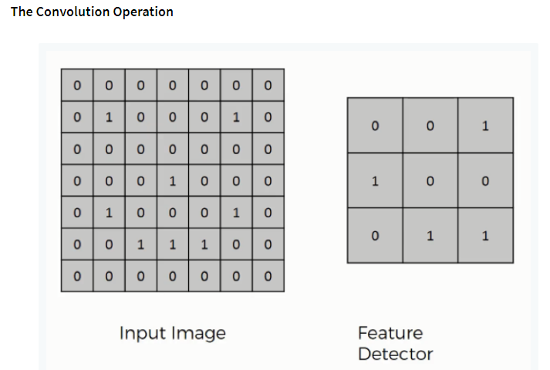

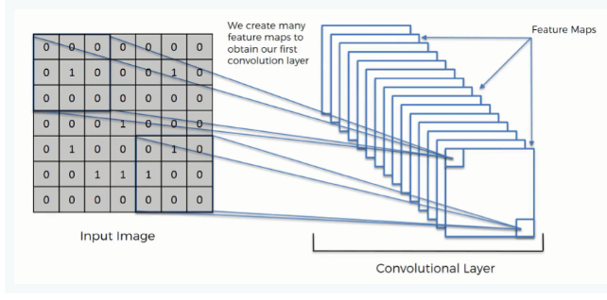

**Figure 5.1.1 Convolutional Neural Network**

**Step (1b): Relu Layer**

The Relook Layer, a crucial part of Convolutional Neural Networks, is discussed, highlighting the function of linearity in Convolutional Neural Networks, despite not being essential for CNN understanding.

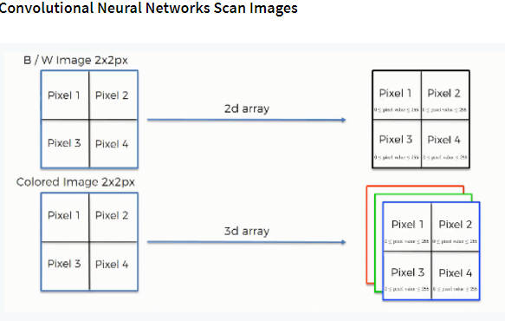

**Figure 5.1.2 Relook layer**

**Step 2: Pooling Layer**

This section focuses on pooling, specifically max pooling, and explores various approaches like mean pooling. A visual interactive tool will be used to demonstrate the concept .

**Step 3: Flattening**

outlines the flattening process in Convolutional Neural Networks, moving from pooled to flattened layers.

**Step 4: Full Connection**

merges all sections, providing a comprehensive understanding of how neurons learn image classification.

**Step 5:** **SVM:**

Support Vector Machine (SVM) is a supervised machine learning algorithm used for classification and regression, aiming to create a hyperplane in an N-dimensional space based on the number of features. It considers two independent variables and one dependent variable, either a blue or red circle.

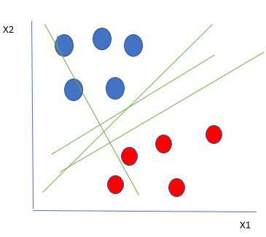

**Figure 5.1.3****Linearly Separable Data points**

**CHAPTER-6**

**SYSTEM DESIGN**

**1 Introduction of Input Design:**

### Input design in an information system involves considering input devices like PCs, MICRs, and OMRs. Quality input determines system output. Well-designed input forms and screens serve specific purposes, ensure accuracy, are easy to fill, and focus on user attention. These objectives are achieved by understanding system inputs and end user responses.

### Objectives for Input Design:

The objectives of input design are −

**User Interaction:**

Design user interfaces for input, allowing users to submit images through an intuitive and user-friendly platform.

**Interpretability Tools Inputs:**

Define inputs for interpretability tools, facilitating user interaction to understand the decision-making process of the CNN model.

**Output Design:**

Output design is a crucial system task that involves identifying required output types, considering necessary output controls, and prototyping report layouts.

**Disease Classification Results:**

Present clear and accurate results of leaf disease classification, indicating the identified disease type along with confidence scores.

**Visualizations for Interpretability:**

Generate visualizations (e.g., heatmaps) highlighting regions of interest in input images, aiding users in understanding which features influenced the model's decision.

**Feedback for Data Augmentation:**

The text provides evaluation of the effectiveness of data augmentation techniques, highlighting their influence on model performance and the diversity of the training dataset.

**Real-time Feedback:**

Implement real-time feedback on the processing status and classification results to users, ensuring a responsive and interactive experience.

**Compatibility with Agricultural Systems:**

Ensure that output formats are compatible with existing precision agriculture systems, allowing seamless integration with broader agricultural technology frameworks.

**Diagnostic Reports:**

Generate comprehensive diagnostic reports for each processed image, detailing the classification outcome, interpretability insights, and any additional relevant information.

**6.2 UML Diagrams:**

**6.2.1 USE CASE DIAGRAM:**

A use case diagram in the Unified Modeling Language (UML) is a behavioral diagram that visually depicts a system's functionality, actors, goals, and dependencies, highlighting their roles

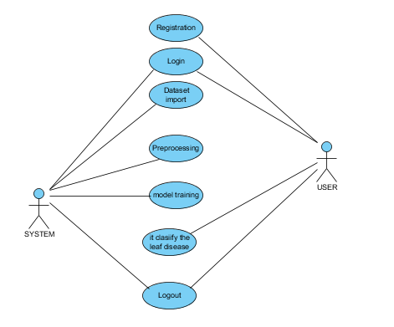

**Figure 6.2.1** **USE CASE DIAGRAM**

**6.2.2 CLASS DIAGRAM:**

A class diagram in the Unified Modeling Language (UML) is a static structure diagram in software engineering that outlines a system's classes, attributes, operations, and relationships. 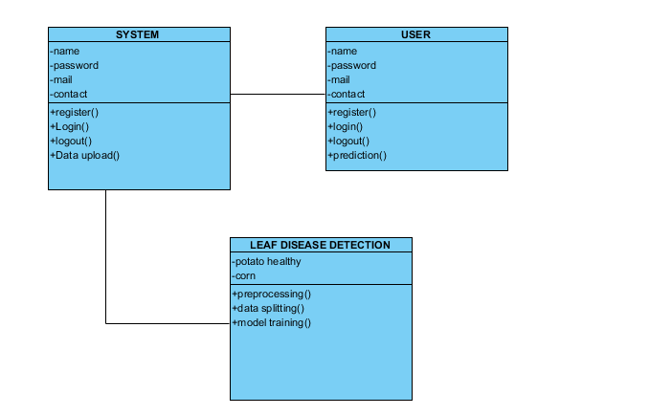

**Figure 6.2.2 CLASS DIAGRAM**

**6.2.3 SEQUENCE DIAGRAM:**

A sequence diagram in Unified Modeling Language (UML) is an interaction diagram that illustrates the order and operation of processes. It is a component of a Message Sequence Chart and is also known as event diagrams, event scenarios, and timing diagrams. 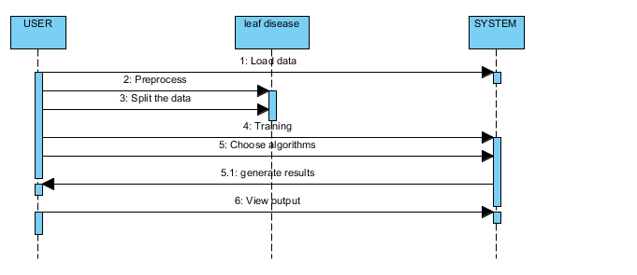

**Figure** **6.2.3 SEQUENCE DIAGRAM**

**6.2.4 COLLABORATION DIAGRAM:**

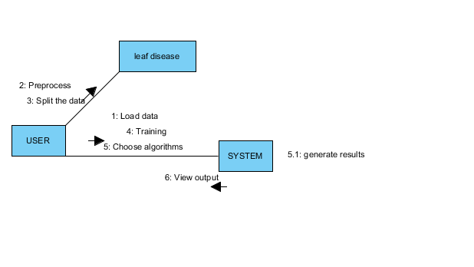The collaboration diagram uses a numbering technique to indicate the method call sequence, indicating how methods are called one after another. This order management system describes the method calls, similar to a sequence diagram, but it does not detail the object organization, unlike the sequence diagram.

**Figure 6.2.4 COLLABORATION DIAGRAM**

**6.2.5 DEPLOYMENT DIAGRAM**

A deployment diagram is a system's deployment view, linked to the component diagram, which consists of nodes, physical hardware used to deploy the application, as components are deployed using these diagrams.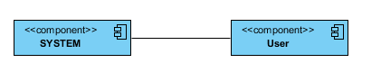

**Figure 6.2.5 DEPLOYMENT DIAGRAM**

**6.2.6 ACTIVITY DIAGRAM:**

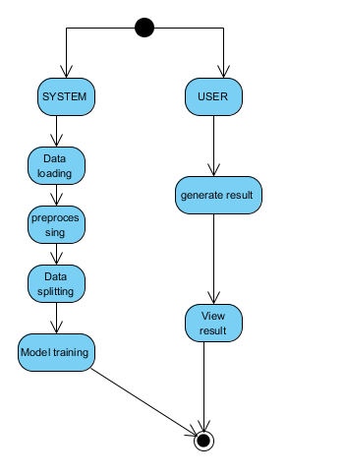Activity diagrams are graphical representations of stepwise workflows in the Unified Modeling Language, allowing for choice, iteration, and concurrency, and do the overall flow of control in a system, describing business and operational workflows.

**Figure 6.2.6 ACTIVITY DIAGRAM**

**6.2.7 COMPONENT DIAGRAM,**

A component diagram, also known as a UML component diagram, is a tool used to organize and wire physical components in a system, ensuring that all necessary functions are covered in the planned development process.

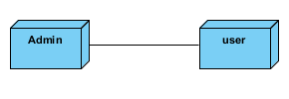

**Figure 6.2.7 COMPONENT DIAGRAM**

**6.2.8 ER DIAGRAM:**

An Entity-relationship model (ER model) is a diagram that describes the structure of a database using the entity set and relationship set. It is a blueprint for implementing a database, focusing on the relationship among entity sets. An entity set is a group of similar entities with attributes, while an entity is a table or attribute of a table in a database. The ER diagram provides a complete logical structure of a database by showing the relationships among tables and their attributes.

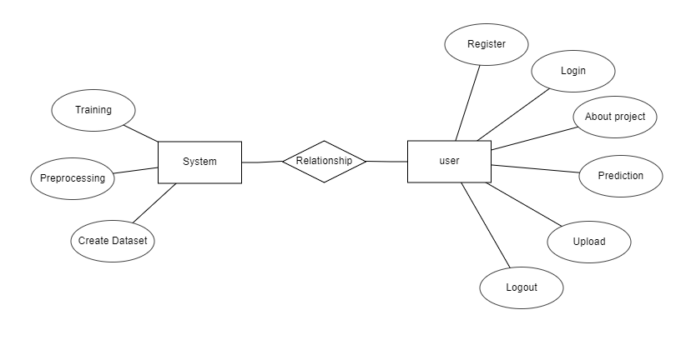

**Figure 6.2.8 ER DIAGRAM**

**6.2.9 DFD DIAGRAM:**

A Data Flow Diagram (DFD) is a visual representation of information flow within a system, illustrating its requirements graphically. It can be manual, automated, or a combination of both. DFDs show how information enters and leaves the system, changes it, and stores it. They serve as a communication tool between systems analysts and system stakeholder. 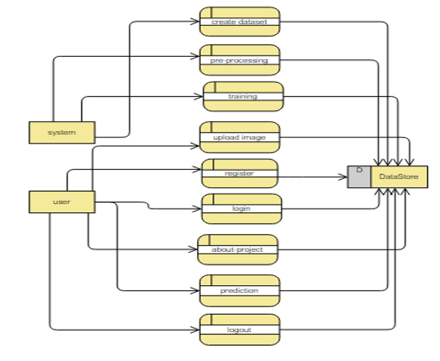

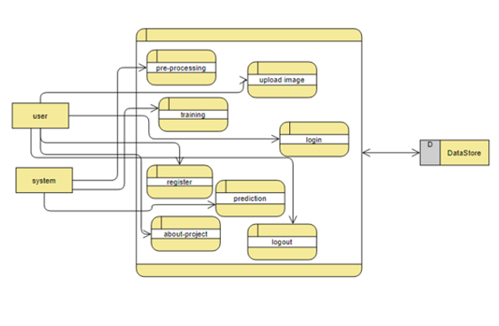 **Figure 6.2.9 DFD DIAGRAM**

**CHAPTER-7**

**IMPLEMENTATION**

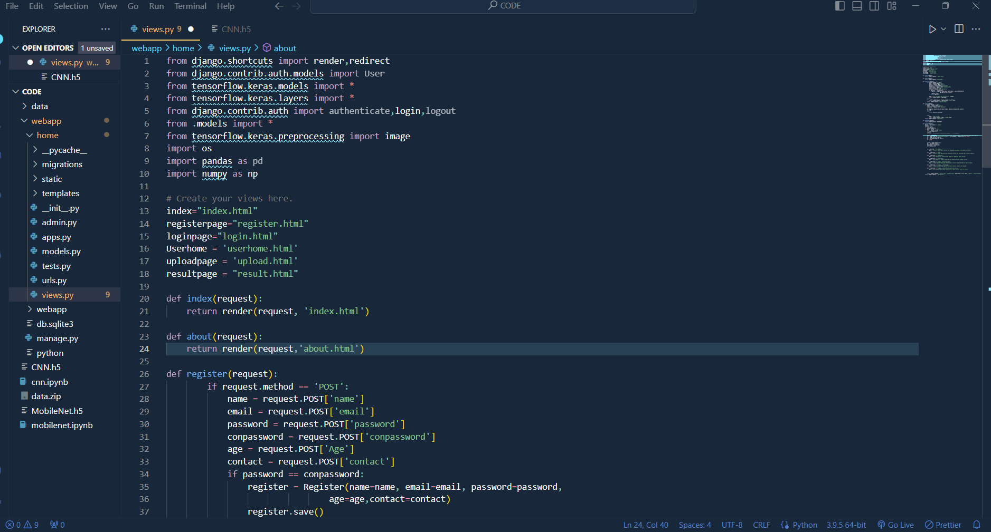

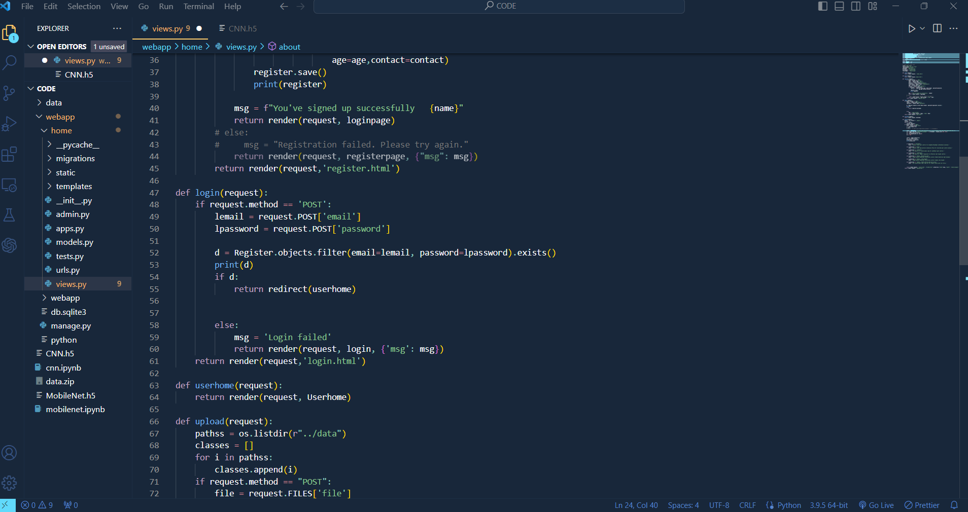

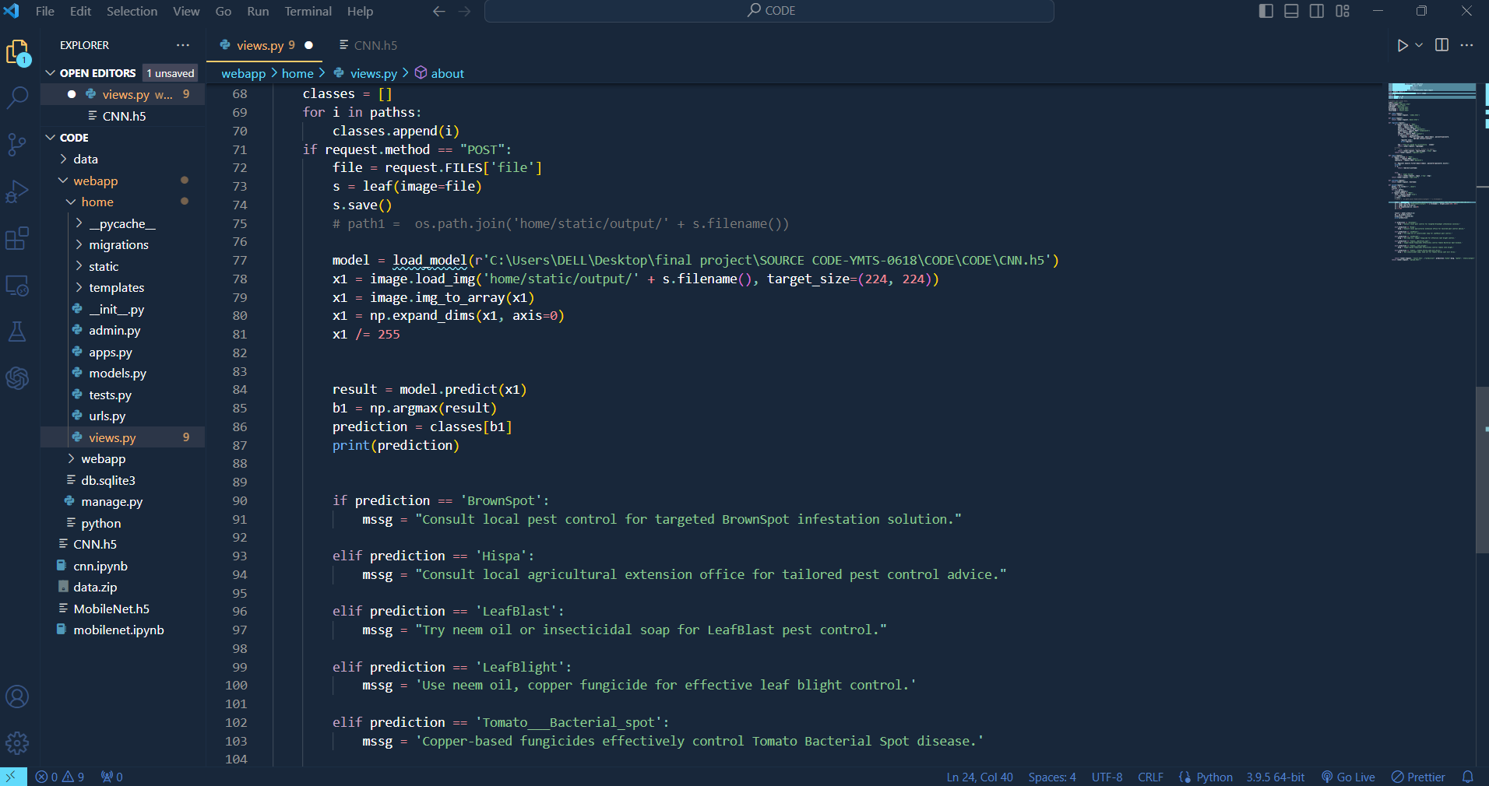

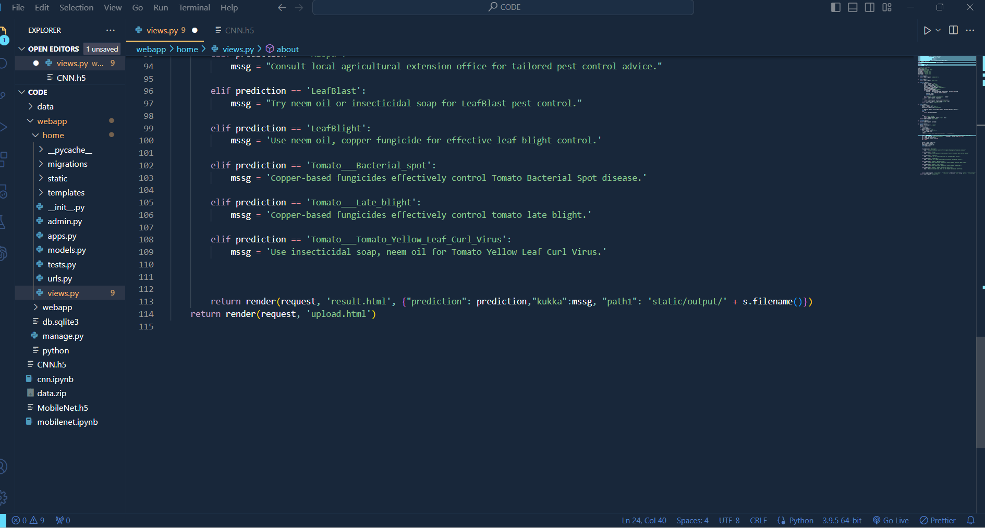

**CHAPTER-8**

**TIMELINE FOR EXECUTION OF PROJECT**

**(GANTT CHART)**

|  |  |  |
| --- | --- | --- |
| **S.NO-** | **Review** | **Dates** |
| 1.Title Finalization with supervisor | Review-0 | 18-10-2023 |
| 2. Methods & Software Details | Review-1 | 15-11-2023 |
| 3. Algorithm Details | Review-2 | 01-12-2023 |
| 4. 50 % implementation details | Review-3 | 21-12-2023 |
| 5. Demonstration | Final viva | 10-01-2024 |

|  |  |  |  |
| --- | --- | --- | --- |
| **Name** | **Start Date** | **End Date** | **Duration** |
| Project Planning | 25-09-23 | 7-10-23 | 12 |
| Requirement Collection | 11-10-23 | 18-10-23 | 7 |
| Research & Analysis | 20-10-23 | 02-11-23 | 12 |
| Designing Project | 04-11-23 | 09-11-23 | 5 |
| Development | 10-11-23 | 12-12-23 | 33 |
| Beta Testing | 13-12-23 | 19-12-23 | 7 |
| Implementation | 20-12-23 | 07-01-24 | 17 |

**CHAPTER-9**

**OUTCOMES**

**Enhanced Accuracy:**

CNN-based leaf disease classification methods consistently outperform traditional methods due to deep learning models' ability to learn intricate patterns and features, resulting in more precise disease identification.

**Robust Generalization:**

The CNN model exhibits robust generalization across diverse datasets and environmental conditions. Traditional methods may struggle with variations in leaf images, while the deep learning model adapts effectively, showcasing its robustness in real-world agricultural scenarios.

**Reduced Dependency on Feature Engineering:**

CNN-based methods, unlike traditional methods that rely on manual feature engineering, automatically learn relevant features from raw data, reducing the need for expert-crafted features and improving system adaptability.

**Efficient Handling of Large Datasets:**

CNNs, with their hierarchical feature extraction, efficiently handle large datasets. This is crucial for training models on extensive collections of labeled leaf images, providing the deep learning model with a substantial knowledge base.

**Discussion:**

The project's superiority over traditional approaches stems from the inherent strengths of CNNs in image classification tasks:

**Hierarchical Feature Learning:**

CNNs automatically learn hierarchical features, capturing intricate patterns in leaf images. Traditional methods often struggle to achieve this level of granularity, leading to reduced accuracy and reliability in disease classification.

**Transfer Learning for Limited Labeled Data:**

The project uses transfer learning on pre-trained CNN models to tackle limited labeled data in agriculture, enhancing performance even with a small dataset by incorporating knowledge from large datasets.

**Adaptability to Varied Environmental Conditions:**

The CNN-based approach showcases adaptability to diverse environmental conditions, a crucial aspect in agricultural settings where lighting, background, and other factors can vary significantly. Traditional methods may falter in such scenarios, compromising the reliability of disease classification.

**Interpretable and Explainable Models:**

CNNs can be enhanced with interpretability mechanisms, providing insights into the decision-making process. This is crucial for gaining trust in the system, especially in agricultural applications where interpretability is essential for user acceptance and decision-making.

**Future-Proofing with Deep Learning Advancements:**

The deep learning model used in this project can benefit from ongoing advancements in CNN architectures and training techniques. This future-proofs the system, allowing for continuous improvement and adaptation to emerging challenges in leaf disease classification.

**CHAPTER-10**

**RESULT- SNAPSHOTS**

**Figure 10.1 Home page**

The homepage serves as the gateway to our Leaf Disease Classification project, providing an intuitive interface for users. Accessible and user-friendly, it offers seamless navigation to explore the project's features, submit leaf images for classification, and access valuable information on deep learning algorithms employed for precise disease identification in agriculture.

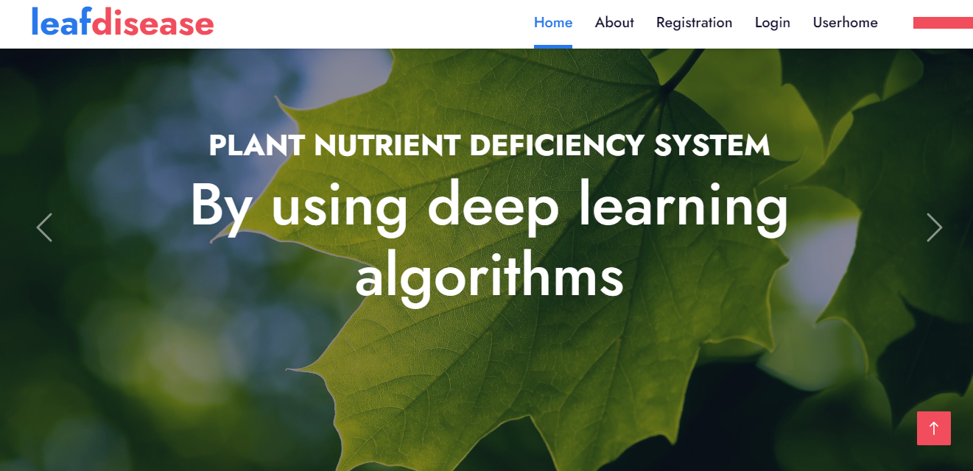

**Figure 10.2 User registration form**

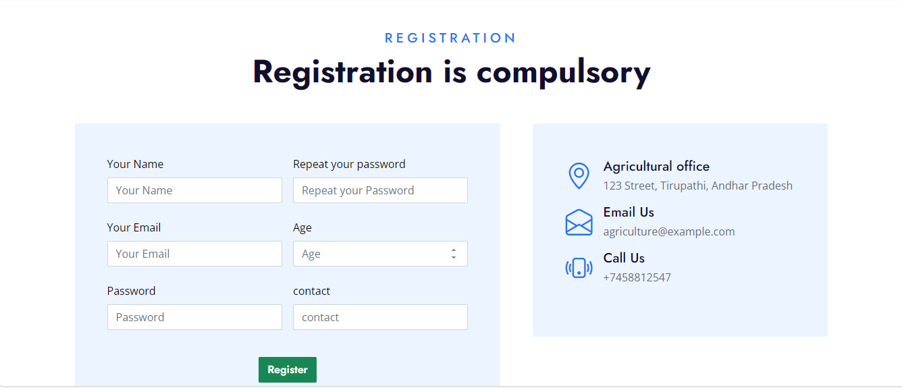The registration page in this project serves as the initial user interface for creating accounts. Users input essential information, including username, email, and password. Advanced security measures ensure data confidentiality. Upon successful registration, users gain access to the leaf disease classification system's features and functionalities.

**Figure 10. 3 User login form**

The login page serves as the initial access point for authorized users in the Leaf Disease Classification project. Users input their credentials to gain entry, ensuring secure access to the system's features and functionalities.

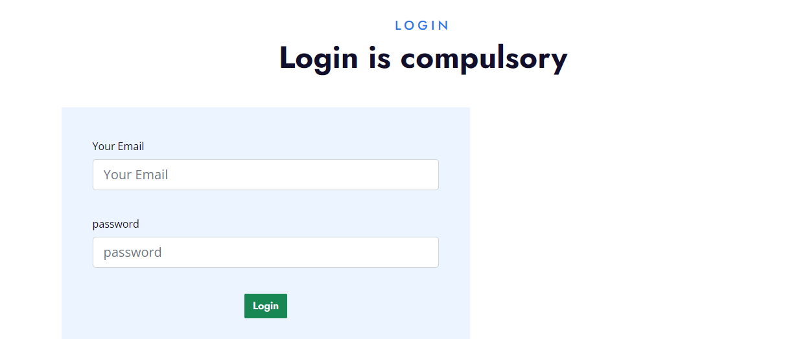

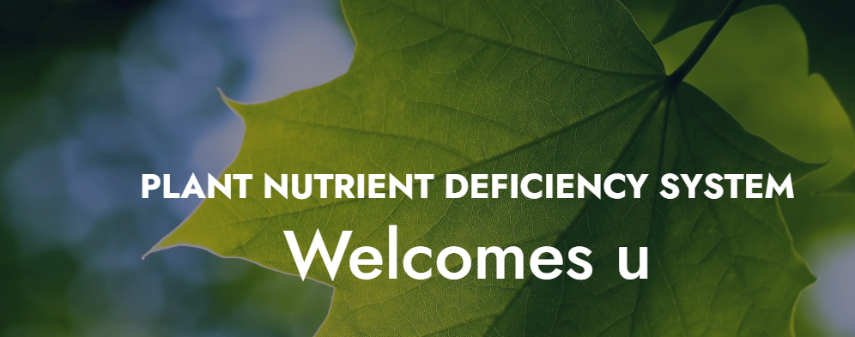

**Figure 10.4: uploading of the image**



**Figure 10.5: Result**

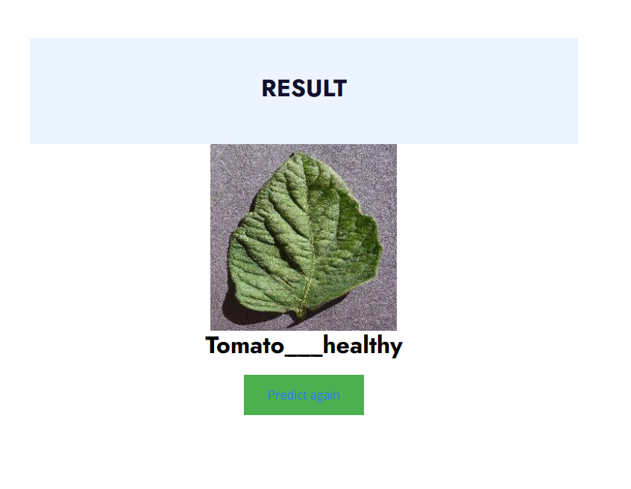

**CHAPTER-11**

**CONCLUSION**

In conclusion, the integration of deep learning for paddy and tomato plant disease detection demonstrates promising advancements in precision agriculture. By leveraging sophisticated neural networks, we can accurately identify diseases, enabling timely intervention and improved crop management. Additionally, the incorporation of pest control recommendations enhances the overall resilience of agricultural systems. This innovative approach not only aids in early disease detection but also contributes to sustainable farming practices, optimizing yield and minimizing environmental impact. The integration of deep learning and agriculture is poised to significantly enhance our ability to tackle global food security challenges.

.

**REFERENCES**

[1] Krizhevsky, A., Sutskever, I., & Hinton, G. E. (2012). ImageNet Classification with Deep Convolutional Neural Networks. In Advances in Neural Information Processing Systems.

[2] Simonyan, K., & Zisserman, A. (2015). Very Deep Convolutional Networks for Large-Scale Image Recognition. In International Conference on Learning Representations.

[3] He, K., Zhang, X., Ren, S., & Sun, J. (2016). Deep Residual Learning for Image Recognition. In Proceedings of the IEEE Conference on Computer Vision and Pattern Recognition.

[4] Goodfellow, I., Bengio, Y., Courville, A., & Bengio, Y. (2016). Deep Learning (Vol. 1). MIT press Cambridge.

[5] Chen, Y., Li, J., Xiao, H., Jin, X., & Yan, S. (2014). Double-projection Robust Principal Component Analysis for Image and Video Background Estimation. IEEE Transactions on Image Processing.

[6] Ronneberger, O., Fischer, P., & Brox, T. (2015). U-Net: Convolutional Networks for Biomedical Image Segmentation. In International Conference on Medical Image Computing and Computer-Assisted Intervention.

[7] Chollet, F. (2015). Keras. GitHub repository. https://github.com/fchollet/keras

[8] Redmon, J., Divvala, S., Girshick, R., & Farhadi, A. (2016). You Only Look Once: Unified, Real-Time Object Detection. In Proceedings of the IEEE Conference on Computer Vision and Pattern Recognition.

[9] Deng, J., Dong, W., Socher, R., Li, L. J., Li, K., & Fei-Fei, L. (2009). ImageNet Large Scale Visual Recognition Challenge. arXiv preprint arXiv:1409.0575.

[10] Szegedy, C., Liu, W., Jia, Y., Sermanet, P., Reed, S., Anguelov, D& Rabinovich, A. (2015). Going deeper with convolutions. In Proceedings of the IEEE Conference on Computer Vision and Pattern Recognition.

**APPENDIX-A**

**PSUEDOCODE**

**from django.shortcuts import render,redirect**

**from django.contrib.auth.models import User**

**from tensorflow.keras.models import \***

**from tensorflow.keras.layers import \***

**from django.contrib.auth import authenticate,login,logout**

**from .models import \***

**from tensorflow.keras.preprocessing import image**

**import os**

**import pandas as pd**

**import numpy as np**

**# Create your views here.**

**index="index.html"**

**registerpage="register.html"**

**loginpage="login.html"**

**Userhome = 'userhome.html'**

**uploadpage = 'upload.html'**

**resultpage = "result.html"**

**def index(request):**

**return render(request, 'index.html')**

**def about(request):**

**return render(request,'about.html')**

**def register(request):**

**if request.method == 'POST':**

**name = request.POST['name']**

**email = request.POST['email']**

**password = request.POST['password']**

**conpassword = request.POST['conpassword']**

**age = request.POST['Age']**

**contact = request.POST['contact']**

**if password == conpassword:**

**register = Register(name=name, email=email, password=password,**

**age=age,contact=contact)**

**register.save()**

**print(register)**

**msg = f"You've signed up successfully {name}"**

**return render(request, loginpage)**

**# else:**

**# msg = "Registration failed. Please try again."**

**return render(request, registerpage, {"msg": msg})**

**return render(request,'register.html')**

**def login(request):**

**if request.method == 'POST':**

**lemail = request.POST['email']**

**lpassword = request.POST['password']**

**d = Register.objects.filter(email=lemail, password=lpassword).exists()**

**print(d)**

**if d:**

**return redirect(userhome)**

**else:**

**msg = 'Login failed'**

**return render(request, login, {'msg': msg})**

**return render(request,'login.html')**

**def userhome(request):**

**return render(request, Userhome)**

**def upload(request):**

**pathss = os.listdir(r"../data")**

**classes = []**

**for i in pathss:**

**classes.append(i)**

**if request.method == "POST":**

**file = request.FILES['file']**

**s = leaf(image=file)**

**s.save()**

**# path1 = os.path.join('home/static/output/' + s.filename())**

**model = load_model(r'C:\Users\DELL\Desktop\final project\SOURCE CODE-YMTS-0618\CODE\CODE\CNN.h5')**

**x1 = image.load_img('home/static/output/' + s.filename(), target_size=(224, 224))**

**x1 = image.img_to_array(x1)**

**x1 = np.expand_dims(x1, axis=0)**

**x1 /= 255**

**result = model.predict(x1)**

**b1 = np.argmax(result)**

**prediction = classes[b1]**

**print(prediction)**

**if prediction == 'BrownSpot':**

**mssg = "Consult local pest control for targeted BrownSpot infestation solution."**

**elif prediction == 'Hispa':**

**mssg = "Consult local agricultural extension office for tailored pest control advice."**

**elif prediction == 'LeafBlast':**

**mssg = "Try neem oil or insecticidal soap for LeafBlast pest control."**

**elif prediction == 'LeafBlight':**

**mssg = 'Use neem oil, copper fungicide for effective leaf blight control.'**

**elif prediction == 'Tomato___Bacterial_spot':**

**mssg = 'Copper-based fungicides effectively control Tomato Bacterial Spot disease.'**

**elif prediction == 'Tomato___Late_blight':**

**mssg = 'Copper-based fungicides effectively control tomato late blight.'**

**elif prediction == 'Tomato___Tomato_Yellow_Leaf_Curl_Virus':**

**mssg = 'Use insecticidal soap, neem oil for Tomato Yellow Leaf Curl Virus.**

**return render(request, 'result.html', {"prediction": prediction,"kukka":mssg, "path1": 'static/output/' + s.filename()})**

**return render(request, 'upload.html')**

**APPENDIX-B**

**SCREENSHOTS**

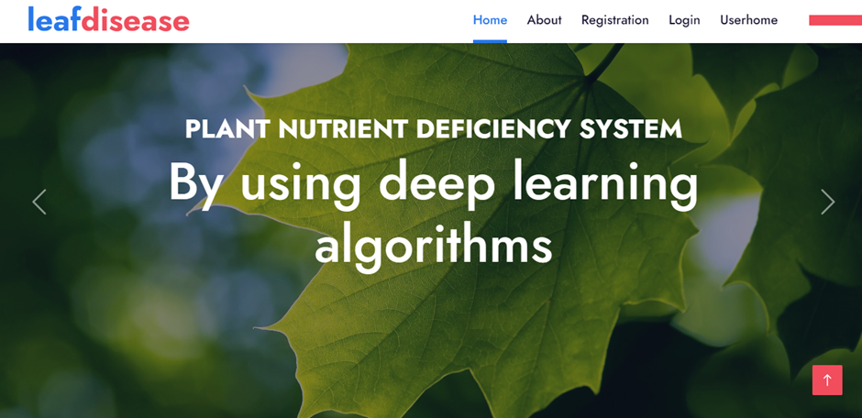

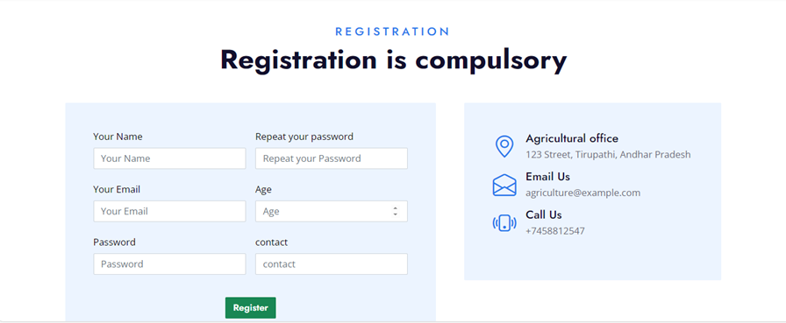

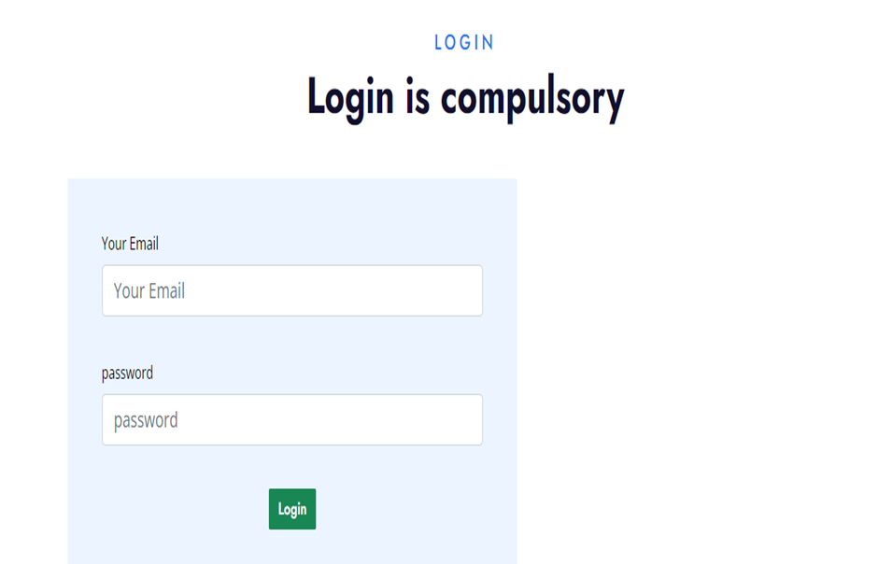





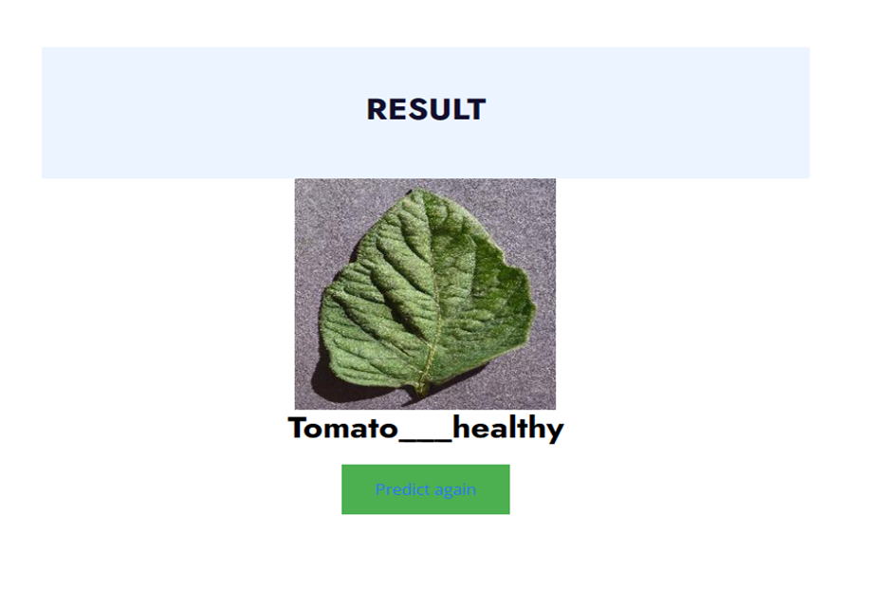

**APPENDIX-C**

**ENCLOSURES**

**1. Conference Paper Presented Certificates of all students.**

**2. Include certificate(s) of any Achievement/Award won in any project related event.**

**3. Similarity Index / Plagiarism Check report clearly showing the Percentage (%). No need of page-wise explanation.**











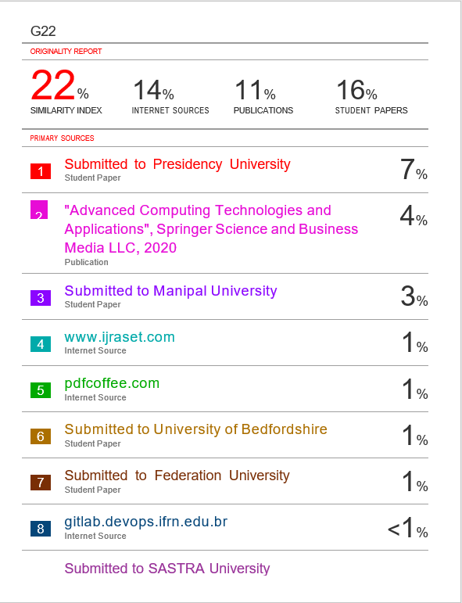



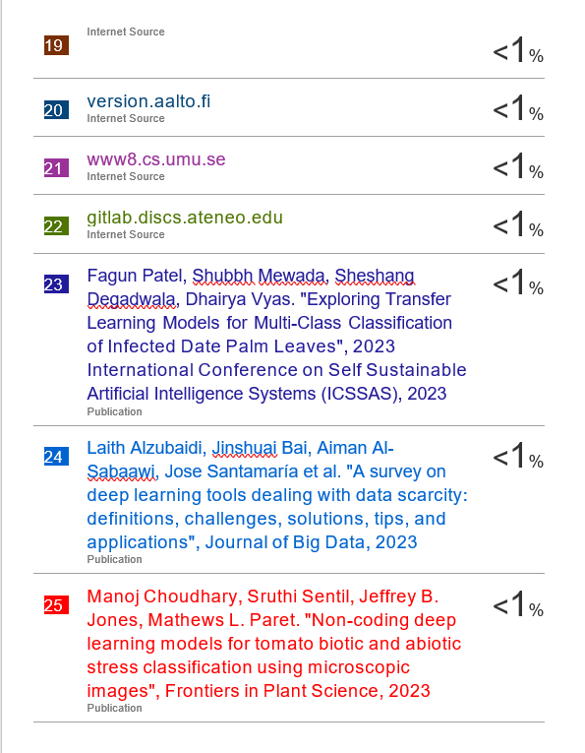

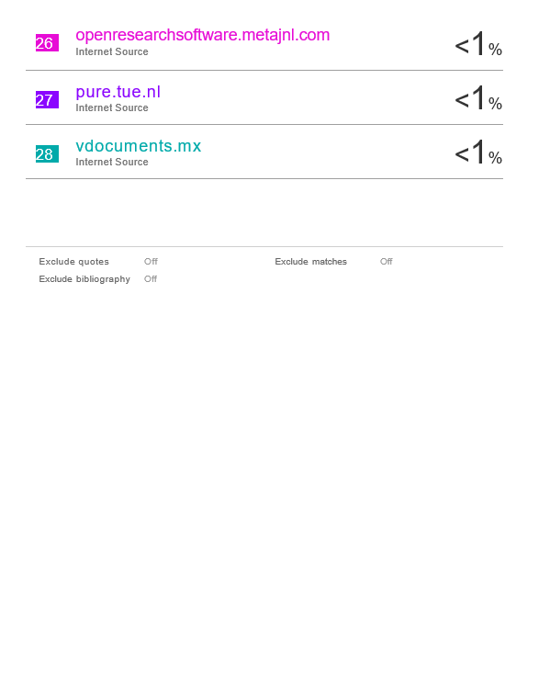

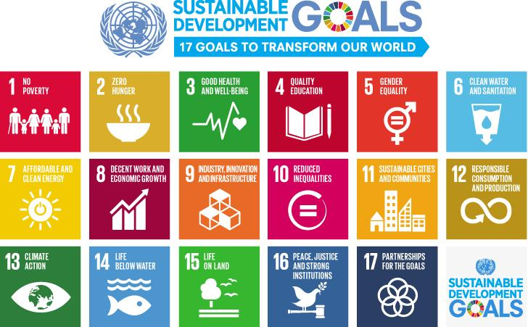

**The project work carried out here is mapped to SDG-12 Responsible Consumption and Production.**

This Project addresses SDG 12 by promoting responsible consumption and production practices in agriculture. The use of advanced technologies for disease detection and pest control enhances the efficiency of crop management, reducing the need for excessive use of pesticides and promoting more sustainable and environmentally conscious farming practices.